**Chapter 4 - Network Layer: The Data Plane**

* Network Layer
  + Transport segment from sending to receiving host
  + On sending side encapsulates segments into datagrams
  + On receiving side, delivers segments to transport layer
  + Network layer protocols in every host, router
  + Router eamines header fields in all IP datagrams passing through it
* Two key network layer functions
  + Forwarding: move packets from router’s input to appropriate router output
  + Routing: determine route taken by packets forms source destination
    - Routing algorithms
* Data Plane
  + Local, per-router function
  + Determines how datagrams arriving on router input port is forwarded to router output port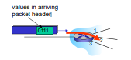
  + Forwarding function
* Control Plane
  + Network-wide logic
  + Determines how datagram is route damong routers along end-end patch from sonic ehost to destination host
  + Two control-plane approaches:
    - Traditional routing algorithms:implemented in routers
    - Software-defined networking(SDN): implements in (remote) servers.
* Per-router control Plane
  + Individual routing algorithm components in each and every router interact in control plan
* Logically centralized control plane
  + A distinct (typically remote) controller interacts with local control agents (CAs)

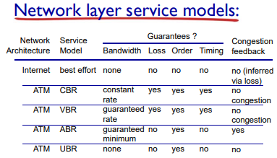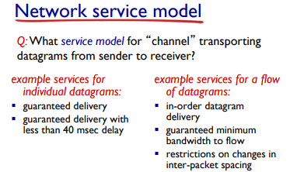

* 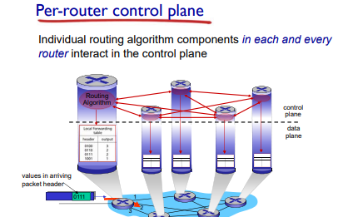
* 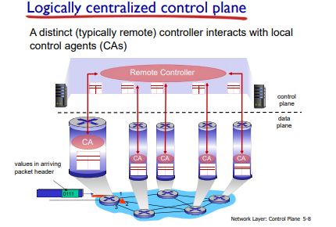

**What’s inside a router?**

* 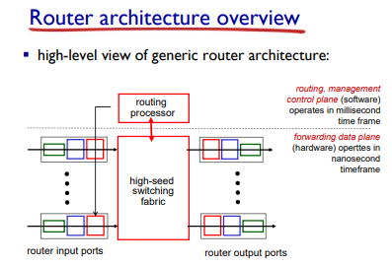
* Input port functions
  + Decentralized switching:
    - Using header field values, lookup output port using forwarding table in input port memory (“match plus action”)
    - Goal: complete input port processing ‘line speed’
    - Queuing: if datagrams arrive faster than forwarding rate into switch fabric
  + 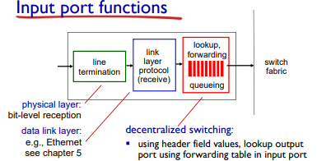
* Longest prefix matching
  + When looking for forwarding tale entry for given destination address, use longest address prefix that matches destination address.
* Switching fabrics
  + Transfer packet from input buffer to appropriate output buffer
  + Switching rate: rate at which packet can be transferred from inputs to outputs
  + Often measured as multiple of input/output line rate
  + N inputs: switching rate N times line rate desirable
  + Three types of switching fabrics; memory, bus, crossbar
  + 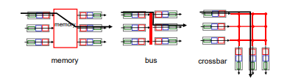
* Switching via memory
  + First gen routers
    - Traditional cmptuers with watching under direct control of CPU
    - Packet copied ot system’s memory
    - Speed limited by memory bandwidth (2 bus crossings per datagram
* Switching via a bus
  + Datagram from input port memory to output port memory via shared bus
  + Bus contention: switching speed limited by bus bandwidth
  + 32 Gbps bus, Cisco 5600: sufficient speed for access and enterprise routers
* Switching via interconnection network
  + Overcome bus bandwidth limitations
  + Banyan networks, crossbar, other interconnection nets initially developed to connect processors in multiprocessor
  + Advanced design: fradmenting datagram into fixed length cels, switch cells through fabric
  + Cisco 12000: switches 60 Gbps through th eintercnnecion network
* Input port queuing:
  + Fabric slower than input ports -> queuing may occur at iput queues
    - Queuing delay an floss due to input buffer overflow
    - H
  + Head-of-the-Line(HOL) blocking: queued datagram at front of queue prevents others in queue from moving forward.
  + 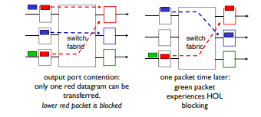
* Output ports
  + Buffering required from fabric faster rate
    - datagram(packets) can be lost due to congestion, lack of buffers
  + Scheduling datagrams
    - Priority scheduling - who gets best performance, network neutrality
  + 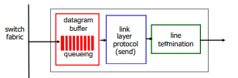
* Output port queuing
  + Buffering when arrival rate via switch exceeds output line speed
  + Queuing (delay) and loss due to output port buffer overflow
  + 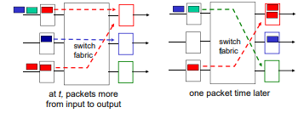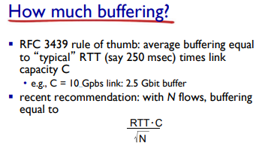
* How much buffering?
* Scheduling mechanisms
  + Scheduling: choose next packet to sendon link
  + FIFO( first in first out) scheduling: send in order of arrival to queue
    - Discard policy: if packet arrives to full queue: who to discard?
    - Tail drop: drop arriving packet
    - Priority: drop/remove on priority basis
    - Random: drop/remove randomly
* Scheduling policies: priority
  + Send highest priority queued packet
  + Multiple classes, with different priorities
    - Class may depend on marking or other header info, eg IP source/dest, port numbers, etc.

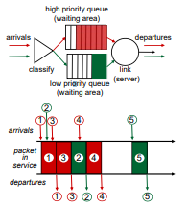

* Scheduling policies: Round Robin(RR) scheduling
  + Multiple classes
  + Cyclically scan class queues, sending one complete packet form each class (if available)
  + 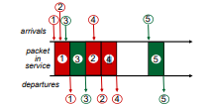
* Scheduling policies; Weighted Fair Queuing (WFQ)
  + Generalized Round Robin
  + Each class gets weights amount of service in each cycle
  + 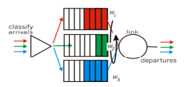
* The Internet Network Layer
  + 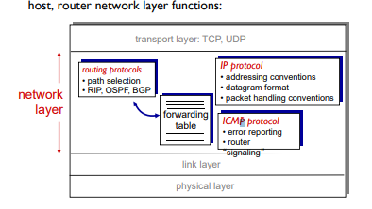
* IP Datagram Format
  + 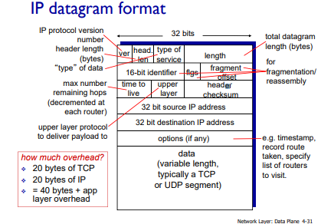
  + Upper layer protocol
    - TCP, UDP